**TOURISM AND HOSPITALITY INDUSTRY - INFECTION PREVENTION AND CONTROL**

**TOPIC 1 -How infections occur**

**Introduction**

Businesses have a legal responsibility to provide a safe service. A risk management approach enables them to take all reasonable precautions. Identifying potential hazards and managing them reduces the likelihood of untoward incidents. Further, the provision of a consistent quality service improves both business reputation and client loyalty. The cost of making everyone safe is small compared with the cost of infecting yourself or a client.

Hospitality industry need to know the precautions required in diseases spread control and anyone working in such a business should implement certain infection prevention and control requirements. Hospitality industry should supply professional, competent, safe, and hygienic practices in clean premises. Unsafe or unhygienic practices can lead to the spread of infectious diseases, which can affect the health of the client and of the operator., Infection prevention and control is important so that you do not transmit a disease or infection to yourself or your clients.

* Infections result from cross-contamination, which happens when the equipment or items you use and the premises you work at are not kept clean, disinfected and/or sterile.
* It is your responsibility to ensure that your clients and your colleagues are safe from infection.
* The cost of having good infection control practices is small compared with the cost of infecting someone.

**Infections – How they occur**

Infection may then occur when:

* Strict hygiene is not observed
* sharing the same equipment or materials
* used and clean items and equipment come into contact with one another
* clean items and equipment are placed on unclean surfaces
* contaminated items such as single-use gloves and masks are not disposed of immediately and appropriately after use
* The structural facilities, furnishings and fittings of the premises cannot be, or are not, adequately cleaned between clients
* towels and other articles used on clients are not changed or thoroughly cleaned between clients.
* contaminated items and equipment are not effectively cleaned and or disinfected before use on another person
* Single-use instruments are not discarded immediately after use.

Both you and your client could become infected if you are in contact with contaminated items and equipment

Remember that an infectious agent such as a virus does not have to be visible on an instrument for infection to be transmitted.

**TOPIC 2-Coronavirus disease a (COVID-19)**

[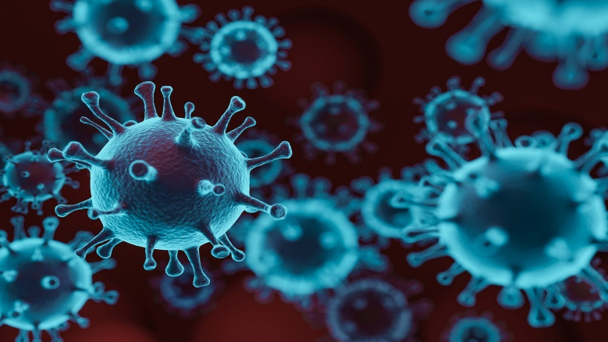](https://www.google.com/url?sa=i&url=http%3A%2F%2Fopiniojuris.org%2F2020%2F06%2F09%2Fa-comparative-analysis-of-covid-19-responses-and-their-effects-on-human-rights-protections-in-east-africa%2F&psig=AOvVaw02kSecYparMVcRybm3GLKc&ust=1593089659256000&source=images&cd=vfe&ved=0CAIQjRxqFwoTCJD888-_muoCFQAAAAAdAAAAABAD)

Coronavirus disease (COVID-19) is an infectious disease caused by a newly discovered coronavirus.

Most people infected with the COVID-19 virus will experience mild to moderate respiratory illness and recover without requiring special treatment.  Older people, and those with underlying medical problems like cardiovascular disease, diabetes, chronic respiratory disease, and cancer are more likely to develop serious illness.

The best way to prevent and slow down transmission is be well informed about the COVID-19 virus, the disease it causes and how it spreads.

**How it spreads**

The virus that causes COVID-19 is mainly transmitted through droplets generated when an infected person coughs, sneezes, or exhales. These droplets are too heavy to hang in the air, and quickly fall on floors or surfaces. Person can be infected by breathing in the virus (e.g. Working together in close proximity or sharing the same environment with a COVID-19 patient or Face-to-face contact within 1 meter) who has COVID-19, or by touching a contaminated surface and then your eyes, nose, or mouth.

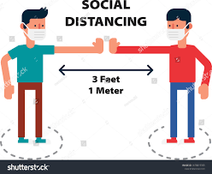

Keeping workers and customers safe during COVID-19 in shops and

branches

**TOPIC 3- Infection prevention and control- Standard -Based Precautions**

**Introduction**

Infection prevention and control uses a risk management approach to minimize or prevent the transmission of infection. The two-tiered approach of standard and transmission-based precautions provides a high level of protection to patients, healthcare workers and other people in healthcare settings. The use of standard precautions is also applicable to and essential for many non-health care settings, such as hospitality industry, personal care, and body art industries.

**Standard precautions** are the work practices required to achieve a basic level of infection prevention and control and are the minimum infection prevention and control practices that must be used at all times for all patients in all situations.  
 **Transmission-based precautions** are used when standard precautions alone are not sufficient to prevent the spread of an infectious agent and are based upon the mode of transmission of the infectious agent.

**Standard precautions**

Standard precautions are a set of infection control practices used to prevent transmission of diseases that can be acquired by contact with blood, body fluids (Saliva, semen, Vaginal fluids, Mucus and Urine), non-intact skin (including rashes), and mucous membranes (such as the nose, mouth, lungs, and stomach). These measures are to be used when providing care to all individuals, whether they appear infectious or not symptomatic.

**Standard Precautions include:**

1. Hand hygiene.
2. Use of personal protective equipment-PPEs (e.g., gloves, masks, eyewear).
3. Respiratory hygiene / cough etiquette.
4. Sharps safety (engineering and work practice controls).
5. Sterile instruments and devices.
6. Clean and disinfected environmental surfaces.
7. **Hand hygiene**

**Welcome dear learner to**

**Learning objective**

* Outline the importance for healthcare personnel to clean their hands to protect their patients and themselves. It will also review methods for hand hygiene. We’ll also learn when healthcare personnel should clean their hands.

So Why All the Fuss About Hand Hygiene?

*Most common mode of transmission of pathogens is via hands!*

[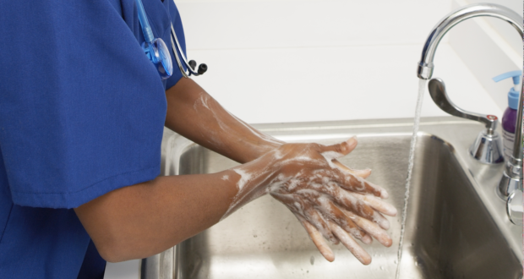](https://www.google.com/url?sa=i&url=https%3A%2F%2Fwww.nursingtimes.net%2Fnews%2Fpolicies-and-guidance%2Fnew-national-hand-hygiene-policy-aims-to-reduce-variation-15-03-2019%2F&psig=AOvVaw3nJh_uHxtKjtk1MLlm28fj&ust=1586950481524000&source=images&cd=vfe&ved=0CAIQjRxqFwoTCMDdnLXp5-gCFQAAAAAdAAAAABAJ)

*Fig 1:*

**Introduction**

Hand hygiene is the single most important Infection Prevention and Control ( IPC) precaution and one of the most effective means to prevent transmission of pathogens associated with health care services. Health care provider and patients should protect themselves from potentially deadly germs by cleaning their hands. Patients in a healthcare setting, are at risk of getting an infection while they are being treated for something else. Patients’ and their loved one’s hands can spread germs too, so they should protect themselves too by cleaning hands often.

Hand hygiene is a general term that applies to either handwashing using plain soap or medicated soap or cleaning agent and water, alcohol-based hand-rub (sanitizers), or surgical hand hygiene prior surgical procedures e. g surgical procedures performed by nurses and doctors in theatre and maternity.

Appropriate hand hygiene must be carried out upon arriving at and before leaving the health care facility, as well as in the following circumstances:

* Before and after performing any procedure between patients or on the same patient
* Before and after coming in direct contact with a client or patient
* Before putting on gloves
* After removing gloves
* After any situation in which hands might become contaminated, such as:

-Handling contaminated objects, including used instruments

-Diapering or toileting children

-Using the toilet, wiping, or blowing one’s nose, or performing other personal functions

-Touching mucous membranes (e.g. nose, mouth, eyes), blood, body fluids, secretions,

or excretions

-Before preparing medication

-Before preparing, handling, serving, or eating food

-Before feeding a patient

[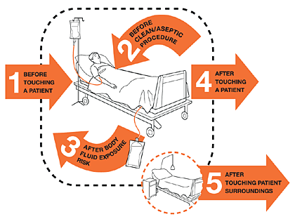](https://www.google.com/url?sa=i&url=https%3A%2F%2Fwww.who.int%2Finfection-prevention%2Fcampaigns%2Fclean-hands%2F5moments%2Fen%2F&psig=AOvVaw1ud6-8yw2z-CF0MCeAS3Zq&ust=1586950564935000&source=images&cd=vfe&ved=0CAIQjRxqFwoTCOjR7Nvp5-gCFQAAAAAdAAAAABAD)

*Fig 2: WHO 5 moments for hand hygiene for healthcare workers*

**Environmental Surfaces Can Look Clean but…**

1. Bacteria can survive for days on patient care equipment and other surfaces like bed rails, IV pumps, etc.
2. It is important to apply hand hygiene after touching these surfaces and at exit, even if you only touched environmental surface.

**Methods**

You can clean your hands two ways, depending on how soiled they are:

* Routine hand washing Soap and water
* Alcohol based hand rub

1. **Routine Hand Washing**

The purpose of hand washing is to remove soil, blood and other organic material, and microorganisms from the skin. The three elements that are essential for effective hand washing are soap, clean running water,1 and friction.

Follow these steps in hand washing:

1. Remove all jewelry.

2. Thoroughly wet hands with running water. Do not dip hands into a basin that contains standing water, even with the addition of an antiseptic agent, because microorganisms can survive and multiply in these solutions. Use a comfortable water temperature. Washing your hands in hot water increases the risk of skin irritation and does not remove more microorganisms.

3. Apply a hand-washing agent (plain soap or detergent). Washing hands with plain water without soap is not effective.

4. Rub all areas of hands and fingers vigorously for at least 20 seconds, paying close attention to fingernails and areas between the fingers. Don’t forget the wrists. Repeat each action five times

5. Remove debris from under the fingernails.

6. Rinse hands thoroughly with clean running water from a tap

7. Use a paper towel when turning off the water if the tap is hand operated.

8. Dry hands with paper towels or air them dry. Avoid using common or shared towels, which might harbor microorganisms and contaminate hands even after proper hand washing or hand rubbing. To avoid sharing towels, use disposable paper, or single- use hand towels. Do not dry hands on personal clothes or on wet and soiled towels. Blow dryers are not recommended.

Patients and family members should be instructed on proper hand washing. Patients should wash their hands before eating, after toileting, and when hands are soiled, under running water with a soap.

Hand-washing products should be handled according to these guidelines:

* For bar soaps, provide soap racks to allow the bar to stay dry, because microorganisms grow and multiply in standing water.
* Store liquid hand-washing products in closed, disposable containers. If reusable containers are used, clean thoroughly and dry them before refilling. Follow routine maintenance schedules and document them. Do not top off liquid-soap containers.
* Rotate the antimicrobial soaps that are used in order to prevent the development of resistant organisms.
* If a liquid hand-washing product requires dilution, have the pharmacy do it.

1. **Alcohol Hand rub without Water** *commonly referred as sanitizers*

The purpose of an antiseptic hand rub is to prevent growth of germs and kill them.

* An antiseptic hand rub is quicker and easier to perform and gives a greater initial reduction in germs.
* Hand rub products also contain a small amount of an emollient/moisturizers such as glycerine, that protects and softens skin.
* When the hands are visibly soiled or contaminated with blood or body fluids, do not use a hand rub—wash hands with soap and water instead.

**Follow these instructions for an appropriate and effective hand rub:**

1. Apply enough alcohol-based hand rub to cover the entire surface of your hands and fingers.
2. Rub the solution vigorously into your hands, especially between the fingers and under the nails until dry.
3. Do not rinse the hands after applying the hand rub.

*Note: Alcohol-based hand rubs are appropriate for rapid hand decontamination between patient contacts. They are not a substitute for hand washing if hands are soiled. To reduce the build-up of emollients/moisturisers on hands after repeated use of alcohol-based hand rubs, wash hands with soap and water after every five hand rubs.*

[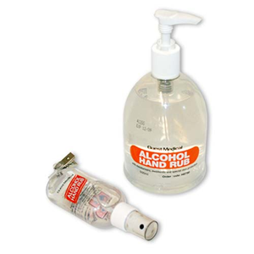](https://www.google.com/url?sa=i&url=https%3A%2F%2Fwww.pinterest.com%2Fpin%2F676665912739547433%2F&psig=AOvVaw3ry4z0uQRipXQqpuzNhRXo&ust=1586951339910000&source=images&cd=vfe&ved=0CAIQjRxqFwoTCJDkuc3s5-gCFQAAAAAdAAAAABAP)

*fig 5: Alcohol based hand rub*

[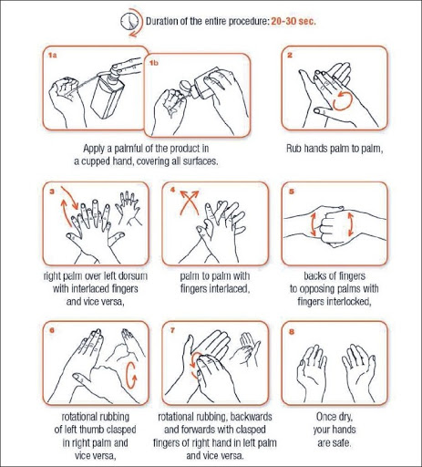](https://www.google.com/url?sa=i&url=http%3A%2F%2Fwww.ijmm.org%2Fviewimage.asp%3Fimg%3DIndianJMedMicrobiol_2010_28_2_100_62483_u4.jpg&psig=AOvVaw3wNIqT9WF7ai2YlEiAXhA5&ust=1586951489309000&source=images&cd=vfe&ved=0CAIQjRxqFwoTCLDB-pLt5-gCFQAAAAAdAAAAABAJ)

*Fig 6: Instructions for hand rub*

[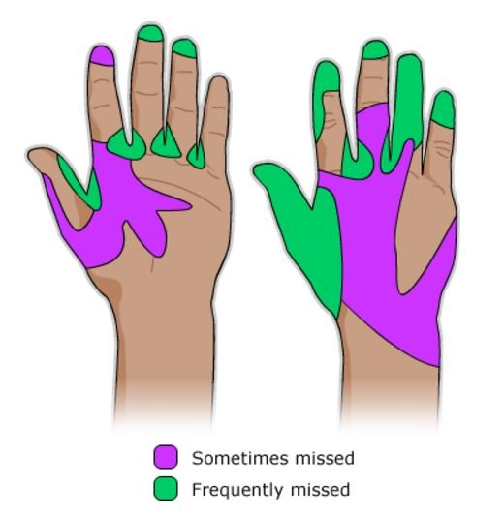](https://www.google.com/url?sa=i&url=https%3A%2F%2Frcni.com%2Fhosted-content%2Frcn%2Ffirst-steps%2Fhand-hygiene&psig=AOvVaw3Pmr3nUbmzQWIotu5qg6_X&ust=1586950744134000&source=images&cd=vfe&ved=0CAIQjRxqFwoTCKCb-7Lq5-gCFQAAAAAdAAAAABAD)

*Fig 7: As you can see, the fingertips, medial areas back of the hand and the thumbs are among the most frequently missed areas in terms of washing*

**Factors that Reduce Hand Hygiene Effectiveness**

**Jewellery:** Rings and bracelets increase germs on hands. Rings also increase the risk of torn or pierced gloves. Jewelry should not be worn during patient care. All jewelry must be removed. In an instance where a bracelet may not be removed due to religious reasons, the bracelet may be pushed as high as possible above the wrist before performing hand hygiene.

**Skin integrity:** Skin cracks, dermatitis, or cuts can trap bacteria and may place patients at an increased risk. Inspect hands for cuts and open sores, and cuticles for tears. Open cuts, sores, or abrasions should be covered prior to starting work. Use barrier creams and lotion after patient care to keep skin healthy and hydrated.

**Artificial nails and nail extenders:** Artificial nails and nail extenders increase the viral load of bacteria up to nine times compared with bacteria found on hands. Extenders or artificial nails are not recommended for health care workers.

**Nail length:** Nails should be a maximum of 1/4-inch long and should not extend past the end of the finger. Most microbes on hands come from under the fingernails. In addition, long nails are harder to clean and may lead to more frequent puncture in gloves from the thumb and forefinger.

**Nail polish:** Nail polish should be freshly applied and be free from chips or cracks. Studies have shown that chipped nail polish and polish older than four days can be a great comfort for germs.

**Water temperature and products:** Hot water increases the likelihood of skin damage.

Below 4 *images show the differences of bacterial growth between clean and unwashed hands*

[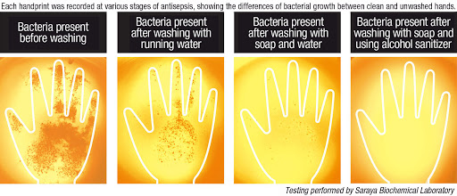](https://www.google.com/url?sa=i&url=http%3A%2F%2Fwww.bestsanitizers.com%2F%3F%2Fglove-juice-hp&psig=AOvVaw2D34k-8HLjnf-Gj1dZZClP&ust=1586954189773000&source=images&cd=vfe&ved=0CAIQjRxqFwoTCNDMpq735-gCFQAAAAAdAAAAABAD)

[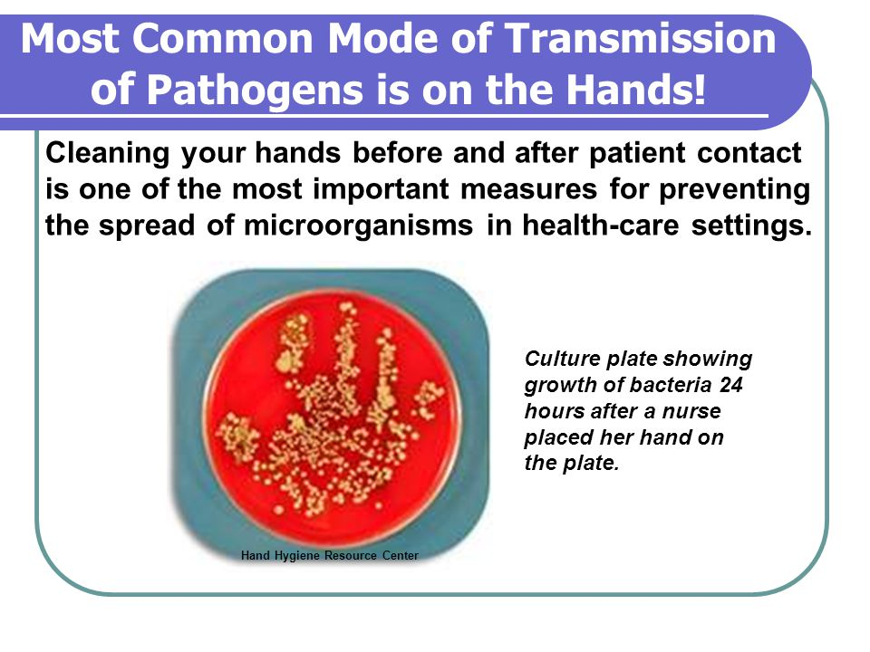](https://www.google.com/url?sa=i&url=https%3A%2F%2Fslideplayer.com%2Fslide%2F4105638%2F&psig=AOvVaw14QRfe1HXQvpqCFdigRFZh&ust=1586955370270000&source=images&cd=vfe&ved=0CAIQjRxqFwoTCOiqhMz75-gCFQAAAAAdAAAAABAc)

[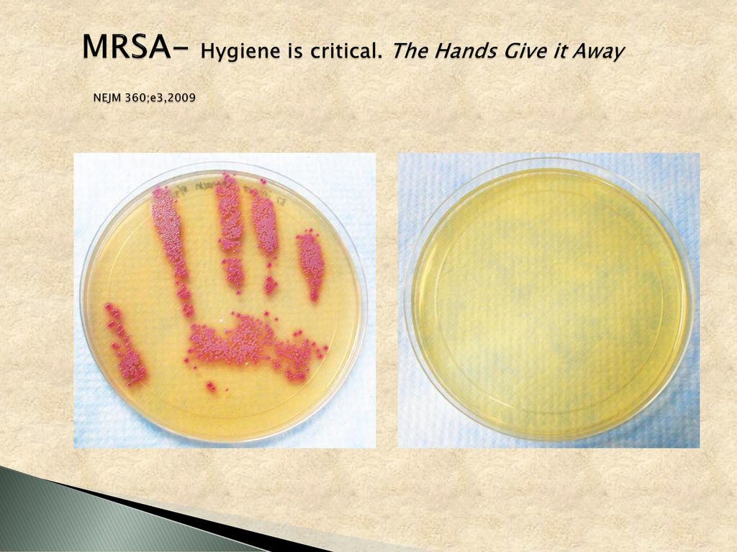](https://www.google.com/url?sa=i&url=https%3A%2F%2Fslideplayer.com%2Fslide%2F12451270%2F&psig=AOvVaw1YAmP0z_wHX19SYDU3ZY8D&ust=1586956166731000&source=images&cd=vfe&ved=0CAIQjRxqFwoTCMDk9Mf-5-gCFQAAAAAdAAAAABAu)

[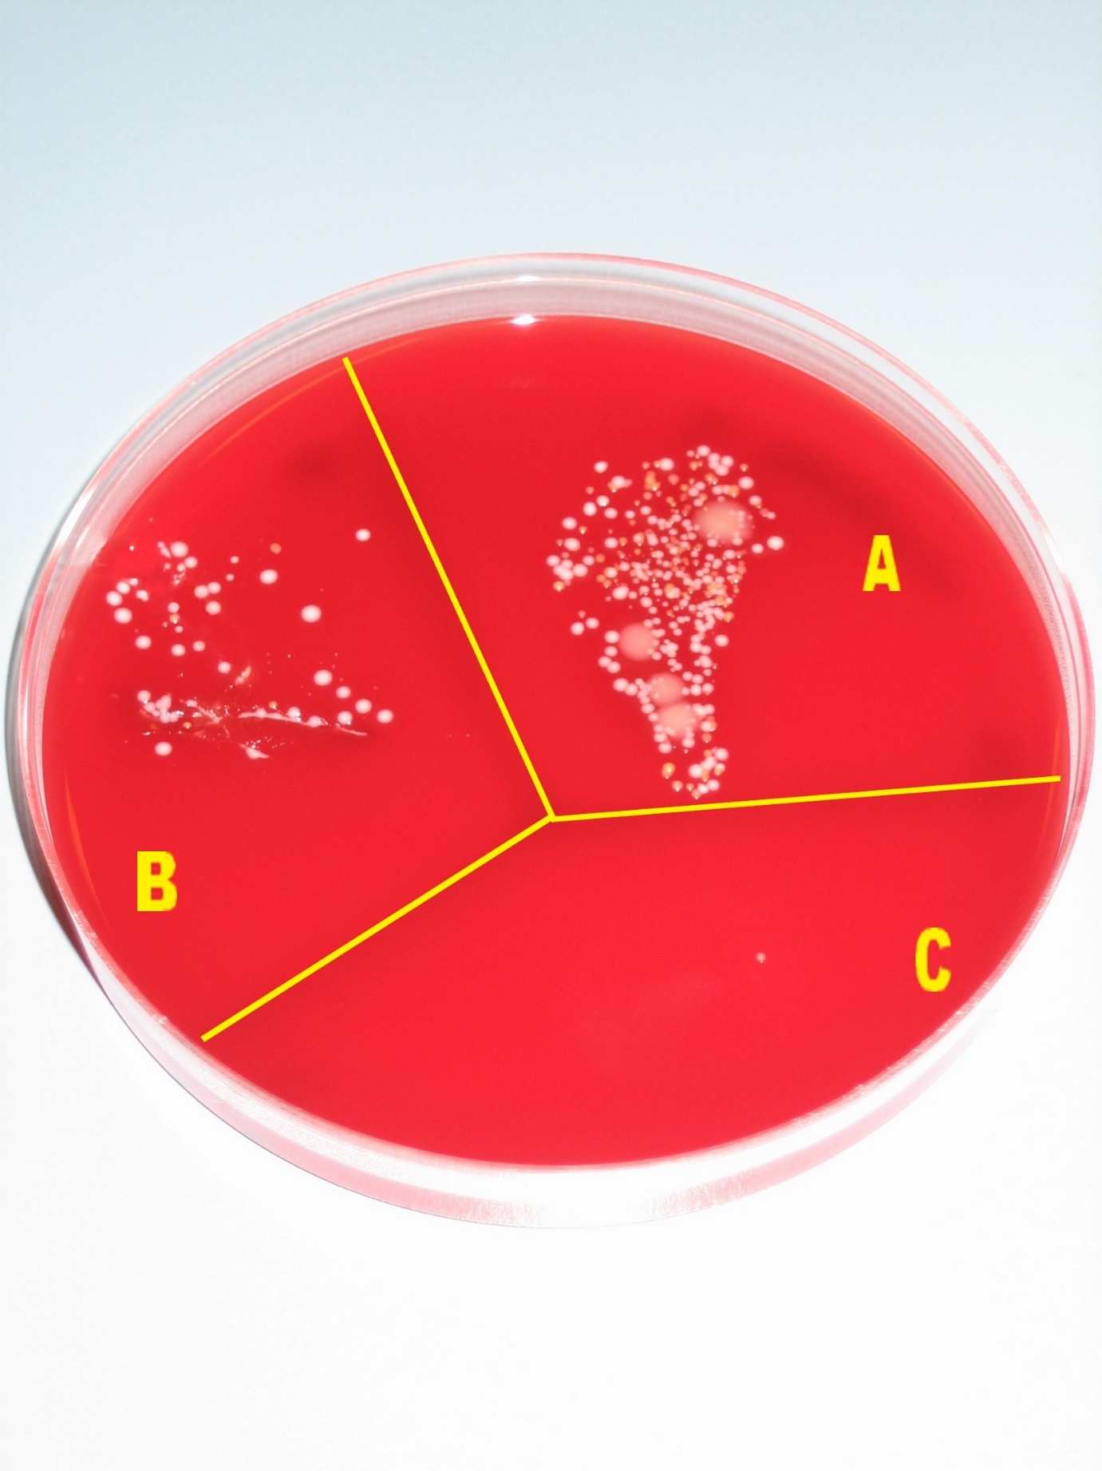](https://www.google.com/url?sa=i&url=https%3A%2F%2Fcommons.wikimedia.org%2Fwiki%2FFile%3AHand_desinfection_test_with_blood_agar_plate.jpg&psig=AOvVaw14QRfe1HXQvpqCFdigRFZh&ust=1586955370270000&source=images&cd=vfe&ved=0CAIQjRxqFwoTCOiqhMz75-gCFQAAAAAdAAAAABBT)

*hand disinfection test.* The picture shows number of germs on hands

In the first sector A, fingers were gently pressed on the [agar plate](https://en.wikipedia.org/wiki/agar_plate) to show the normal number of germs on the hands. The hands were washed with water and soap and pressed on sector B. Fewer grow on the plate after the hand washing procedure. Then the hands were disinfected with 70 - 80 % alcohol, and pressed on sector C. The

number of microbes and microbe species have decreased radically in this simple test showing the importance of hand hygiene.

**HAND CARE FOR HEALTH CARE PROVIDERS**

For healthcare professionals, the combination of proper hand hygiene and washing hands countless times each day can cause skin to become dry, chapped and irritated. Learning how to care for your hands can help protect them from damage and discomfort.

*** As a healthcare professional, you can’t avoid hand hygiene. But you can avoid dry, damaged skin by starting a hand care routine.

Here are a few suggestions on how to sooth those hands:

* 1. [**Lotion**](https://cna.plus/dry-skin-helpful-tips/)

Lotions are effective to keep your skin moisturized. Such products should be water- based and without fragrance.

Petroleum-based lotion formulations can weaken latex gloves and increase permeability. Lotions that contain petroleum or other oil emollients should only be used at the end of the workday.

2. [**Emollients**](https://www.medicalnewstoday.com/articles/182953.php)

Emollients - creams and oils - are moisturizers that provide an extra layer of protection to the skin. These are found in a wide range of products and can add a layer of oil to the skin to slow down water loss, increase its capacity to retain moisture and lubricates to reduce friction. These three functions aid the skin in repairing itself. A few examples of emollients to try are cocoa butter, shea butter and animal and plant oils such as aloe and lanolin, which is like our skin's own natural oils. Apply a liberal amount to the hands and wrap before bed.

**3.Use cold or warm water to wash your hands:**

It’s the soap and friction of good handwashing that kills germs. Hot water strips away the skin’s natural oils, causing even more damage.

1. **Don’t rub your hands when you dry them**

The rough surface of a paper towel can aggravate your skin, so just use it to blot them i.e. pat dry.

1. Use non-irritant hand hygiene detergents/products
2. **If possible, avoid hand dryers that blow hot air**

Hot air can do as much damage as a rough paper towel. If you’re using an air dryer, it takes 30-45 seconds to dry hands.

Healthcare personnel that develop skin irritation should inform their supervisors.

**ALERT SAFETY:** It is important to follow instructions for use for commercially available products. These instructions may contain additional directions or warnings unique to that product.

**Personal Protective Equipment**

Protective barriers and clothing are referred to as personal protective equipment, or PPE, and have been used for many years to protect clients from microorganisms present on HCWs in the health care setting. With the emergence of HIV/AIDS and Hepatitis B and C virus, COVID-19 and the increase of TB, PPE has now become important for protecting HCWs as well as clients.

PPES includes masks, eye/face shields, gloves, gowns and aprons. Types of PPE are required, depending on the level of exposure and the risk of transmission. Whatever the level of PPE to be used, PPE will only protect you and others from harm if you are able to put it on, use it, remove it and dispose of it in the correct manner. Getting it wrong at any of these stages can lead to germs being passed on.

Some items are for single-use only – that is, you MUST use them once and then discard them – while others are retained, cleaned and reused.

* PPE provides a physical barrier between microorganisms and the wearer, thereby preventing microorganisms from contaminating hands, eyes, clothing, hair, and shoes.
* PPE also prevents microorganisms from being transmitted to other patients and staff.
* PPE reduces, but does not completely eliminate, the risk of acquiring an infection.

*Note: Use of PPE does not replace the need to follow basic* important Infection Prevention and Control (IPC) *measures such as hand hygiene.*

**Principles for Using PPE**

Health care workers should follow these guidelines for using PPE:

▪ Assess the risk of exposure to blood, body fluids, excretions, or secretions and choose items of PPE accordingly.

▪ Use the right PPE for the right purpose.

▪ Avoid any contact between contaminated (used) PPE and surfaces, clothing, or people outside the patient care area.

▪ Discard used PPE appropriately in designated disposal bags.

▪ Do not share PPE.

▪ Change PPE completely and thoroughly your wash hands each time you leave a patient to attend to another patient or another duty.

The following individuals should use PPE:

▪ Health care workers who provide direct care to patients and who work in situations in which they might have contact with blood, body fluids, excretions, or secretions

▪ Support staff, including waste handlers, cleaners, and laundry staff, in situations in which they might have contact with blood, body fluids, excretions, or secretions

▪ Laboratory staff who handle patient specimens

▪ Family members who provide care to patients and could come in contact with blood, body fluids, excretions, or secretions

**Gloves**

Gloves should be worn in addition to, not as a substitute for, hand washing. Hand hygiene coupled with the use of protective gloves is a key component in minimizing the spread of disease and maintaining an infection-free environment.

Understanding when gloves are required and, equally important, *when they are not required*, can reduce costs and maintain safety for both patients and staff.

**Recommended Use**

When there is a reasonable chance of hands coming in contact with blood or other body fluids, mucous membranes, or nonintact skin. Before handling contaminated waste items or touching contaminated surfaces

Gloves are expensive irrespective of who is paying for them. They should not be worn when it is not necessary to do so. Gloves are not required if there is no anticipated contact with mucous membranes, blood, body fluids, secretions, or excretions (for example, for routine care activities in which contact is limited to a patient’s intact skin, such as checking blood pressure, checking temperature, or giving IM injections). The appropriate type of gloves should be used for the appropriate reason (for example, use sterile gloves only for the necessary purpose).

**The following types of gloves:**

Sterile surgical gloves – Always used when performing surgical procedures e. g during surgery and maternity

▪ Disposable (single use) examination gloves

▪ Utility or heavy-duty gloves (for use in cleaning instruments, equipment, contaminated surfaces, and while handling or disposing of contaminated waste)

Clean, nonsterile, disposable gloves (that is, nonsurgical gloves) are adequate in the following situations:

▪ When providing routine care for patients who have highly transmissible infections like COVID-19

▪ When there is a reasonable chance of hands coming in contact with blood or other body fluids, mucous membranes (e. g nose, mouth and eyes or any moist areas in a body like urethra etc) or nonintact skin (open skin lesions)

▪ For contact with blood, body fluids, secretions, excretions, mucous membranes, draining wounds, or nonintact skin.

* When handling items that are visibly soiled with blood, body fluids, secretions, or excretions

▪ When the HCW has nonintact skin on his or her hands

▪ Before performing invasive medical procedures, for example, inserting vascular devices such as peripheral venous lines

▪ Before handling contaminated waste items or touching contaminated surfaces

**The general principles for using gloves:**

▪ Put gloves on directly before contact with the patient or just before the task or procedure that requires the gloves.

To prevent cross-contamination of body sites, change gloves between care activities and

procedures with the same patient after contact with materials that may contain high concentrations of microorganisms (after handling an indwelling urinary catheter for example).

▪ Remove gloves before moving to another patient.

▪ Wear gloves while handling laboratory specimens e. g stool and urine.

▪ Remove gloves immediately after completing care or a specified task, at the point of use, and before touching clean environmental surfaces.

▪ Wash and dry hands immediately after removing gloves.

▪ Do not wash, decontaminate, and reuse single-use disposable gloves. They do not provide

adequate protection after reprocessing.

▪ Do not wear gloves while walking in corridors and riding in elevators.

▪ All staff should wear appropriate gloves prior to contact with blood, body fluids, secretions, or excretions from any client or patient.

▪ Use a separate pair of gloves for each client to avoid cross-contamination.

* Handling potentially harmful substances, such as disinfectants.

*Note that disposable gloves are NOT necessary for many parts of routine day-to-day care, like helping a patient/client to wash and dress or bed-making.*

**Putting on**

* Select correct glove size and type.
* Perform hand hygiene.
* Pull to cover wrists.

\[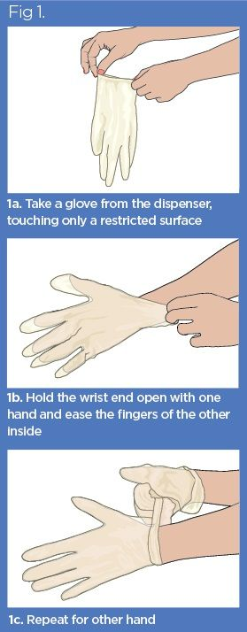](https://www.google.com/url?sa=i&url=https%3A%2F%2Fwww.nursingtimes.net%2Fclinical-archive%2Finfection-control%2Finfection-control-3-use-of-disposable-gloves-and-aprons-24-06-2019%2F&psig=AOvVaw2AGYns-8SWpPqTVN3xbZAF&ust=1586952187950000&source=images&cd=vfe&ved=0CAIQjRxqFwoTCOC2neLv5-gCFQAAAAAdAAAAABAD)

* When you’ve finished the procedure:
* Take the gloves off, avoiding touching the outer surfaces (which are likely to be contaminated with germs), and dispose of them in the correct waste-disposal system.

[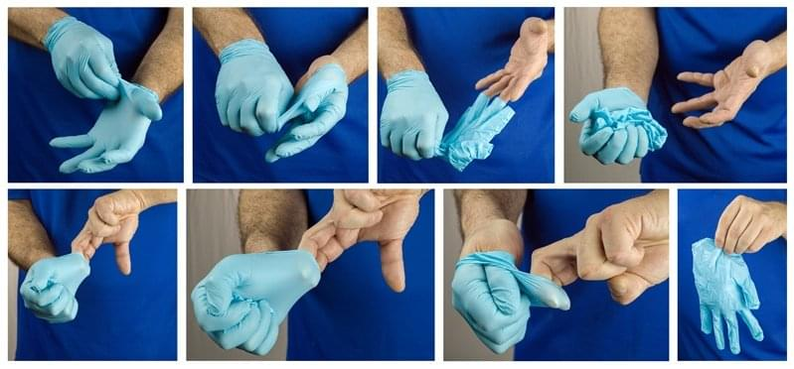](https://www.google.com/url?sa=i&url=https%3A%2F%2Fwww.deliteconstruction.com%2Fwhat-is-donning-gloves%2F&psig=AOvVaw0rN9wn3mTmDyygQ4VTdsbm&ust=1586952863416000&source=images&cd=vfe&ved=0CAIQjRxqFwoTCLj18qDy5-gCFQAAAAAdAAAAABAO)

* Change gloves and perform hand hygiene during patient care, if
  + gloves become damaged,
  + gloves become visibly soiled with blood or body fluids following a task,
  + moving from work on a soiled body site to a clean body site on the same patient or between different tasks with the same patient/client
* Never wear the same pair of gloves in the care of more than one patient.
* Carefully remove gloves to prevent hand contamination.
* never wash or reuse

**Warning!**

Some gloves have a substance called ‘latex’ that can cause serious allergies. If you know you have an allergy to latex, you must tell your employer so that alternative gloves can be supplied. You will also be told when patient/clients have latex allergies and mustn’t have contact with latex gloves.

### **Safe Work Practices**

* Keep hands away from face
* Limit surfaces touched
* Change when torn or heavily contaminated gloves
* Perform hand hygiene
* Healthy skin is less likely to permit growth of microbes that may be picked up during patient care. Cuts and abrasions on cuticles, hands, and forearms should be covered with waterproof dressings. If covering them in this way is not possible, surgical staff with skin lesions should not operate until the lesions heal. Health care workers who have open sores or cuts on their hands or forearms should not process instruments until the lesions are healed.